Corporations Section P.O.Box 13697

Austin, Texas 78711-3697

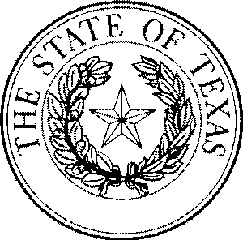

Office of the Secretary of State

**CERTIFICATE OF FILING OF**

# ATLAS Knives LLC

File Number: 806032523

# Jane Nelson

Secretary of State

The undersigned, as Secretary of State of Texas, hereby certifies that a Certificate of Formation for the above named Domestic Limited Liability Company (LLC) has been received in this office and has been found to conform to the applicable provisions of law.

**ACCORDINGLY,** the undersigned, as Secretary of State, and by virtue of the authority vested in the secretary by law, hereby issues this certificate evidencing filing effective on the date shown below.

The issuance of this certificate does not authorize the use of a name in this state in violation of the rights of another under the federal Trademark Act of 1946, the Texas trademark law, the Assumed Business or Professional Name Act, or the common law.

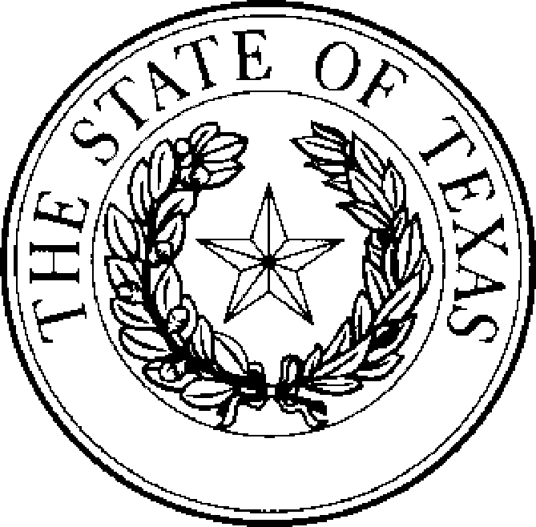Dated: 05/12/2025 Effective: 05/13/2025

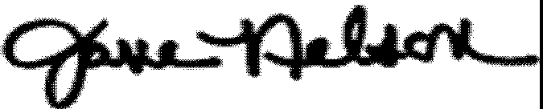

Jane Nelson Secretary of State